

Mid Term Report

on

**Virtual AI Career Advisor**

### Project-I

**BACHELOR OF TECHNOLOGY**

(Computer Science and Engineering.)



## SUBMITTED BY:

Team Member 1 - Nikhil Kumar (2230813)

Team Member 2 - Gaurav Sharma (2230771)

Team Member 3 - Jitesh Jaswal(2230784)

Team Member 4 - Konal Sharma(2230789)

Jan 2025

**Under the Guidance of**

Ms. Jaspreet Kaur

Assistant Professor(CSE)

# Department of Computer Science & Engineering Chandigarh Engineering College Jhanjeri Mohali - 140307

## Table of Contents

|  |  |  |
| --- | --- | --- |
| **SNo** | **Contents** | **Page No** |
| 1. | Introduction | 1-3 |
| 2. | System Requirements | 4 |
| 3. | Software Requirement Analysis | 5-7 |
| 4. | Software Design | 8-12 |
| 5. | Implementation | 13-18 |
| 6. | Reference | 19-20 |

## Table of Contents

|  |  |  |
| --- | --- | --- |
| **SNo** | **Contents** | **Page No** |
| 1. | Fig. 4.2.1 – Data Flow Diagram | 9 |
| 2. | Fig. 4.4.1 – ER Diagram | 11 |

**Introduction**

* 1. **Overview**

Career path choice is one of the most important decisions a person can make, as it will have a major impact on her future success and fulfillment. Due to the numerous choices available in a variety of fields, many individuals have difficulty choosing a career path that is compatible with their abilities, interests, and objectives. Traditional career counseling approaches, such as one-on-one consultations, can be time-consuming, expensive, and often inaccessible to many individuals. The rapid advancements in artificial intelligence (AI) have created new opportunities for intelligent solutions that provide personalized career guidance. By employing AI-driven suggestions, users of the Virtual AI Career Advisor can explore career possibilities that align with their education, skills, and preferences. The platform provides individualized recommendations, potential job roles, and opportunities for skill development by evaluating user information. This AI-based strategy guarantees quick, data-driven advice that is easily scalable and accessible.

* 1. **Inspiration**

The difficulties in choosing a suitable career path, which can be influenced by a variety of factors including personal interests, skills, market trends, and industry advancements, are the source of the motivation for this project. Due to a lack of adequate guidance, a significant number of people, particularly students and recent graduates, struggle with career decisions. Existing career advisory services often fall short in providing personalized, real-time insights that resonate with an individual's aspirations and capabilities. The Virtual AI Career Advisor was created to tackle this issue by offering an AI-powered platform that provides instant and customized career suggestions. By analyzing user data including educational history, skill sets, and career goals, the system is designed to deliver tailored guidance that assists individuals in making informed decisions. This initiative aims to improve the accessibility, effectiveness, and accuracy of career counseling while reducing dependence on human involvement.

* 1. **Significance of AI-Driven Career Guidance**

As new job opportunities arise across various sectors, the employment landscape is changing swiftly. Traditional career guidance methods often fall behind these developments, leading to outdated advice. AI-enriched career advisory tools address this issue by continuously analyzing current industry trends and aligning them with an individual's profile.

Key benefits of AI-based career guidance include:

• Tailored Recommendations – AI assesses personal user data to provide career suggestions that reflect their unique strengths and interests.

• Quick and Scalable Support – Unlike traditional counseling approaches, AI-driven platforms can serve multiple users simultaneously, ensuring accessibility for all.

• Data-Informed Decision Making – AI utilizes extensive datasets to offer recommendations based on job market trends, necessary skillsets, and industry growth.

• Ongoing Career Support – The system proves beneficial at every stage of an individual’s career, from students selecting their first job to professionals contemplating career changes.

By leveraging AI-driven career counseling, users can gain actionable insights that help them successfully manage their career journeys.

* 1. **Uses of AI-Enhanced Career Guidance**

The Virtual AI Career Advisor provides numerous applications across different fields:

• Guidance for Students: This service aids students in discovering careers compatible with their interests and educational backgrounds.

• Support for Job Seekers & Recent Graduates: Offers job suggestions based on skills and potential career pathways.

• Assistance for Working Professionals: Helps those aiming to switch careers, recommends upskilling options, and identifies opportunities for advancement.

• Recruitment & Human Resources: Aids recruiters in matching candidates with suitable job openings through AI-driven insights.

• Educational Institutions: Delivers AI-supported assistance to career counseling programs in schools, colleges, and universities.

This AI-driven approach ensures that individuals receive relevant, current, and data-backed career guidance at every stage of their professional development.

* 1. **Issues in AI-Powered Career Guidance**

Despite the advantages of AI-enabled career advisors, certain challenges need to be addressed to enhance their effectiveness:

• Precise Data Analysis: AI must accurately interpret user input to offer relevant career advice.

• Ongoing Industry Updates: The system needs to remain current with evolving job markets, emerging careers, and shifting skill requirements.

• Customization for Users: Career guidance should be tailored specifically to individual strengths, weaknesses, and preferences.

• Ethical Considerations: AI must ensure unbiased recommendations, steering clear of career suggestions influenced by incorrect data patterns.

• Accessibility of Technology: Users with limited technical skills should find the platform straightforward and user-friendly.

Overcoming these challenges will improve the credibility and functionality of the AI-driven career advisor, ensuring that users receive valuable and future-oriented career guidance.

**1.6 Objectives**

1. Assess current methods of career counseling and emphasize their strengths, weaknesses, and AI-driven improvements.
2. Utilize Groq LLM to produce precise, personalized career guidance based on user input.
3. Develop a user-friendly React.js frontend with seamless state management and API interactions.
4. Employ JSON files to temporarily store user session data, eliminating the need for a database.
5. Suggest career transitions, pertinent courses, and certifications for skill enhancement.

**1.7 Tools Learnt**

* **React.js**
  + Purpose: Build an interactive frontend interface.
  + Key Points: routing, a component-based architecture, and hooks like useState and useEffect.
* **Flask / FastAPI**
  + Purpose: Lightweight backend for handling requests and AI integration.
  + Key Points: Restful API endpoints, JSON response handle, file-based session management.
* **Groq LLM API**
  + Purpose: AI-powered career analysis without training a custom model.
  + Key Points: Prompt design, handling AI responses, managing API credentials.
* **Git/GitHub**
  + Purpose: Version control and collaborative development.
  + Key Points: Branching, merging, pull requests, maintaining code history.

**Software Requirements**

* 1. **Development Environment**
* **Programming Language:** Python (Backend), JavaScript (Frontend - React.js)
* **IDE/Code Editor:**
  + **VS Code** (Recommended for both frontend & backend development).
  + **Jupyter Notebook** (For testing API responses).

**2.2 Machine Learning & AI Integration**

* **LLM API:** **Groq API** for natural language processing and career recommendations.
* **API Request Handling:** requests and FastAPI (for backend).

**2.3 Frontend Framework**

* **React.js** (Used to create an interactive UI).
* **State Management:** React Hooks (useState, useEffect).

**2.4 Backend Framework**

* **FastAPI/Flask** (Lightweight backend for handling API calls).

**2.5 Deployment & Hosting**

* **Frontend Hosting:** Netlify (for deploying React frontend).
* **Backend Hosting:** Render or Replit (for Flask/FastAPI server).

**Software Requirement Analysis**

**3.1 Problem**

Choosing a career is among the most vital choices a person can make, yet numerous students and professionals find it challenging due to inadequate guidance, limited exposure to industries, and struggles to grasp market demands. Conventional career counseling methods depend on human experts, tend to be costly and time-consuming, and often lack personalization tailored to an individual’s abilities and passions.

Given the swift technological advancements and the constant evolution of job roles, it is essential for individuals to adopt a data-driven approach to career guidance. The Virtual AI Career Advisor aims to deliver immediate and personalized career suggestions utilizing Artificial Intelligence (AI) and Natural Language Processing (NLP). By evaluating user inputs such as educational qualifications, skills, interests, and career aspirations, the system recommends career options, necessary skills, and appropriate courses to fill any knowledge gaps.

In contrast to traditional counseling, which depends on human involvement, this AI-driven system offers ongoing learning and real-time adjustments in response to the latest industry developments. The system operates without a database and employs a lightweight, efficient structure utilizing JSON files for user profile storage, ensuring seamless functionality and straightforward deployment..

**Key Obstacles in Choosing a Career**

* Limited Awareness: A lot of people are not informed about the wide range of career possibilities that exist.
* Skill and Industry Mismatch: Numerous job seekers do not possess the specific skills needed for various career paths.
* Time and Financial Limitations: Conventional career counseling can be both time-intensive and expensive for students and professionals.
* Changing Job Market: New job roles frequently arise, necessitating ongoing skill development.
* Uniform Guidance: Traditional counseling typically offers broad suggestions instead of customized advice.

The Virtual AI Career Advisor tackles these issues by delivering immediate, personalized career guidance, assisting users in making educated career choices based on their interests, capabilities, and market requirements.

**3.2 Modules and Their Functionalities**

The Virtual AI Career Advisor is divided into multiple modules, each handling a specific task in the career recommendation process.

**3.2.1. User Authentication & Profile Management**

* Allows users to register/login using a simple form.
* Stores user details (name, education, skills, interests) in a local JSON file for easy access.
* Enables users to update or modify their career preferences over time.
* Ensures data privacy by keeping user information stored locally instead of in a database.

**3.2.2. Career Interest Selection Module**

* Users can manually select career domains they are interested in (e.g., IT, Healthcare, Finance, Marketing).
* If a user is unsure, the AI suggests potential career paths based on previous academic performance and skills.
* The module also asks personality-based questions to understand user interests.

**3.2.3. AI-Powered Career Analysis Module**

* Uses Groq LLM (Large Language Model) to process user input and generate career recommendations.
* Matches user skills and education with current job market trends.
* Uses AI-based algorithms to predict the best job roles for a user based on industry demand.

**3.2.4. Skill & Course Recommendation Module**

* Provides a list of essential skills required for the user’s recommended career paths.
* Recommends online courses and certifications from platforms such as Coursera, Udemy, and LinkedIn Learning.
* Identifies gaps in the user’s skills and suggests relevant learning resources.

**3.2.5. Career Report Generation Module**

* Generates a personalized career report that includes:
  + **Recommended careers** based on user input.
  + **Job market demand** for each suggested career path.
  + **Essential skills** needed for each career.
  + **Salary expectations** and future job growth trends.
* Allows users to download or save the career report for future reference.

**3.2.6. Resume Review & Improvement Module**

* The system allows users to upload their resumes (in text format).
* Uses AI to analyze and suggest improvements to enhance resume quality.
* Highlights missing keywords, skills, and achievements based on the user’s target career field.

**3.2.7. Interview Preparation Module**

* Provides AI-generated common interview questions related to the user’s selected career.
* Uses NLP to offer feedback on responses (if implemented with voice processing).
* Recommends mock interview practice sessions and best practices for job interviews.

**3.2.8. Real-Time Career News & Updates Module**

* Retrieves latest job trends, career updates, and skill demands from publicly available sources.
* Provides news feeds about emerging job opportunities in different industries.
* Keeps users informed about upcoming certifications and job fairs.

**3.3 System Workflow**

The following steps outline how the Virtual AI Career Advisor works:

* User Registration/Login – The user enters basic details and creates a profile.
* Career Interest Selection – The user selects career fields of interest.
* AI-Based Analysis – The system processes user inputs and evaluates career options.
* Career Recommendations – The AI suggests career paths based on education, skills, and market demand.
* Skill Gap Identification – The system checks for missing skills required for recommended careers.
* Course & Certification Suggestions – Users receive a list of online learning resources.
* Career Report Generation – The system creates a detailed career report for the user.
* Resume Review & Suggestions – Users can upload resumes for AI-based improvements.
* Interview Preparation – The system provides common questions and practice tests.
* Real-Time Career Updates – Users receive industry news and trends relevant to their chosen career path.

**3.4 Key Advantages of the System**

* **Personalized Career Guidance :** Unlike traditional counseling, which provides general advice, this AI-based system tailors recommendations to individual preferences.
* **Real-Time Insights :** The system continuously learns from updated job market data, ensuring users receive current and relevant career suggestions.
* **Cost-Effective & Time-Saving :** Since the Virtual AI Career Advisor is an automated system, it eliminates the need for expensive career counseling sessions.
* **Data Privacy & Security :** Unlike cloud-based services, this system does not store data on external servers, ensuring user privacy.
* **No Database Dependency :** The system is lightweight and stores user data in JSON files, reducing complexity.

# Software Design

**4.1 System Architecture**

The system is designed with a modular and lightweight framework that promotes efficiency and rapid responsiveness. Its architecture encompasses several layers, each designated for a particular function within the system. The primary components include:

**4.1.1 User Interface (Frontend)**

The user interface (UI) aims to deliver an engaging and fluid experience for users. It gathers user input and presents AI-generated career suggestions. The frontend's responsibilities include:

* Input Handling: Receiving career-related inquiries from users.
* Real-Time Interaction: Offering immediate responses through AI-generated recommendations.
* User Experience Optimization: Improving user engagement via an intuitive design and straightforward navigation.

The UI is constructed utilizing HTML, CSS, JavaScript, and React.js, thereby ensuring dynamic and responsive interactions.

**4.1.2 Backend Logic**

The backend processes user inquiries, interacts with the AI model, and sends structured responses back to users. The core functionalities of the backend include:

* Request Processing: Accepting user inputs, checking their validity, and relaying them to the AI model.
* AI Model Integration: Engaging with the AI API to obtain career guidance based on user inquiries.
* Response Formatting: Organizing AI-generated information meaningfully prior to delivering it to the frontend.

The backend is implemented using Flask or FastAPI, facilitating efficient and lightweight handling of APIs.

**4.1.3 AI Integration**

The central element of the system is the AI-driven career advisory module. This component utilizes Large Language Models (LLMs) to interpret user inputs and produce insightful recommendations. The AI integration includes:

* Natural Language Processing (NLP): Comprehending user inquiries and extracting significant context.
* Career Knowledge Base: Employing pre-trained AI models that encompass a wide range of career-related information.
* Personalized Suggestions: Customizing recommendations in accordance with user inputs and preferences.

The system uses Groq LLM API, which is designed for efficient and intelligent text processing, ensuring relevant and high-quality career guidance.

**4.1.4 Session Management**

While the system does not retain user data indefinitely, it implements a session-based method to uphold continuity. Sessions temporarily hold:

* User Queries: To facilitate a more tailored experience throughout the session.
* AI Responses: Allowing users to review and modify their career inquiries.

This approach ensures a smooth and consistent user experience without requiring a dedicated database.

**4.2 Data Flow Diagram (DFD)**

The Data Flow Diagram (DFD) depicts the logical progression of information within the system. It outlines how user inputs are managed and how the AI model interacts with the backend. Since the system does not utilize a database, the DFD emphasizes data movement between the various components.

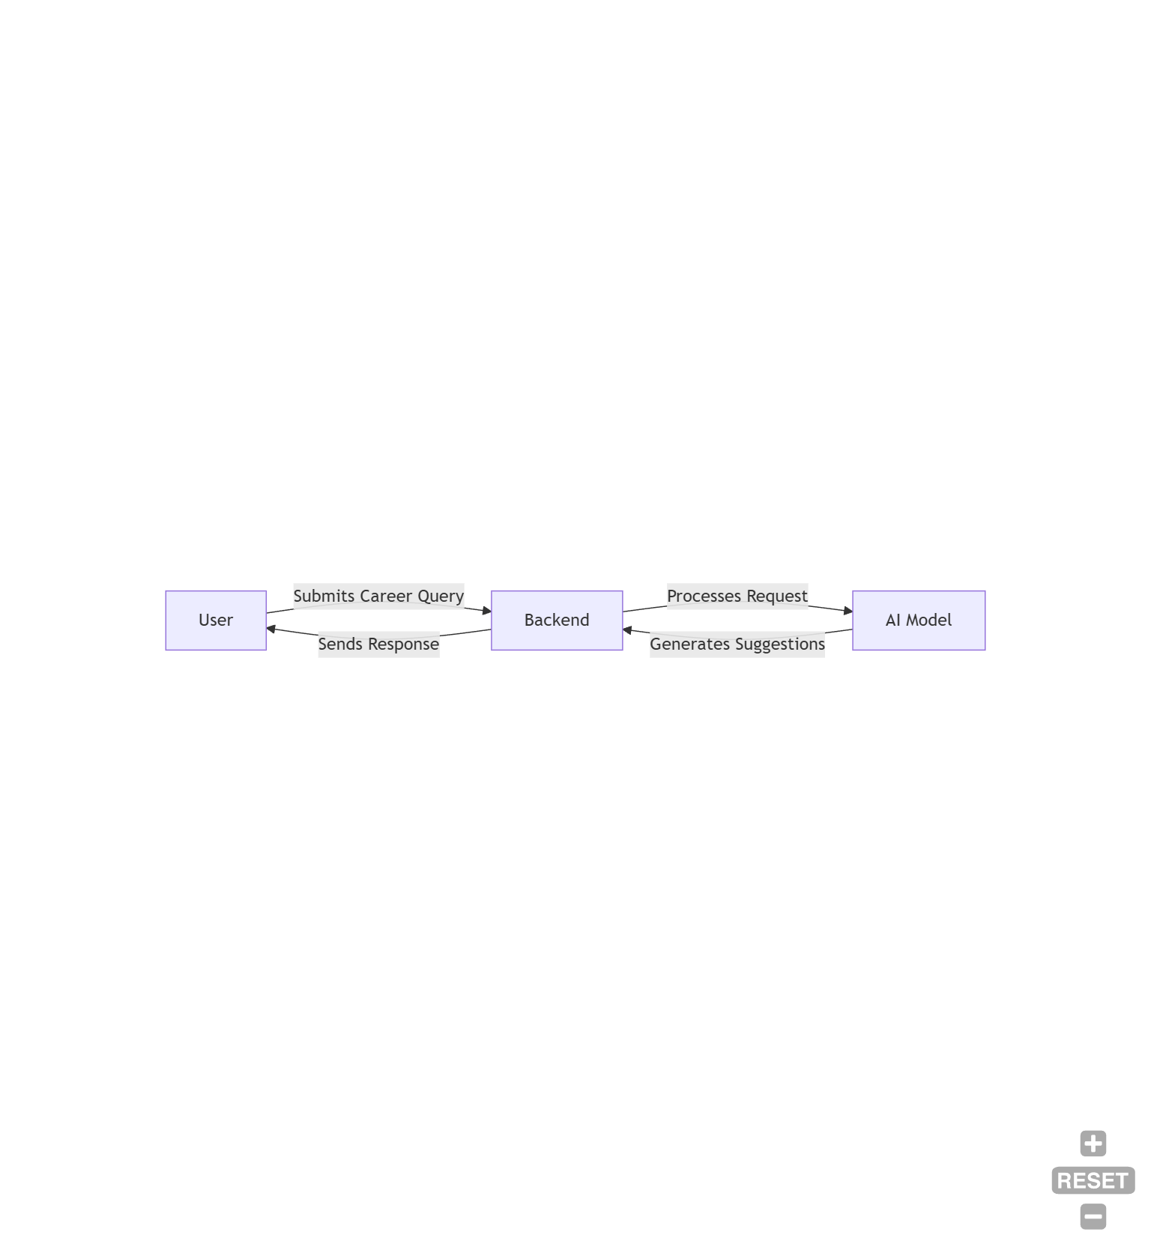

Fig. 4.2.1

**4.2.1 Level 0 DFD (Context Diagram)**

At the top level, the system is represented as a black box featuring essential interactions:

* The user poses a question related to career guidance.
* The backend processes the inquiry and forwards it to the AI model.
* The AI model evaluates the question and produces career suggestions.
* The formatted response is then sent back to the user.

This methodology guarantees that career advice is provided effectively.

**4.2.2 Level 1 DFD (Detailed Process Flow)**

Level 1 DFD elaborates on the main components:

**4.2.2.1. User Interaction**

* The user enters a career-related question via the web interface.
* Input validation checks for mistakes or irrelevant questions.

**4.2.2.2. Processing Layer**

* The backend receives the inquiry and processes it according to established rules.
* The system communicates with the AI API to evaluate the query.

**4.2.2.3. AI-Based Career Analysis**

* The AI model produces career recommendations based on the user's input.
* Additional information, such as skill requirements or job market dynamics, may be included.

**4.2.2.4. Response Handling**

* The processed response is formatted for display.
* The result is presented to the user interactively.

This organized approach guarantees that all inquiries are handled efficiently.

**4.3 System Component Design**

Each module within the system plays an important role in maintaining seamless functionality. The system is categorized into the following essential components:

**4.3.1 User Input Handling**

* Receives and verifies career-related questions.
* Ensures proper formatting of queries before forwarding them to the AI model.

**4.3.2 AI Processing Unit**

* Evaluates the query using natural language processing techniques.
* Gathers pertinent career suggestions from the knowledge base.

**4.3.3 Response Generation**

* Formats the responses generated by the AI in a way that is user-friendly.
* Ensures that career recommendations are clear and concise.

**4.3.4 User Experience Optimization**

* Improves response interactivity through suggestions and follow-up questions.
* Allows users to adjust their queries based on the provided feedback.

These components together construct the foundational system design, facilitating a smooth and effective AI-driven career advisory experience.

**4.4 Logical Relationship Between Entities**

Given that the system does not utilize a database, a conventional Entity-Relationship (E-R) Diagram is not relevant. However, we can depict logical connections among system entities as follows:

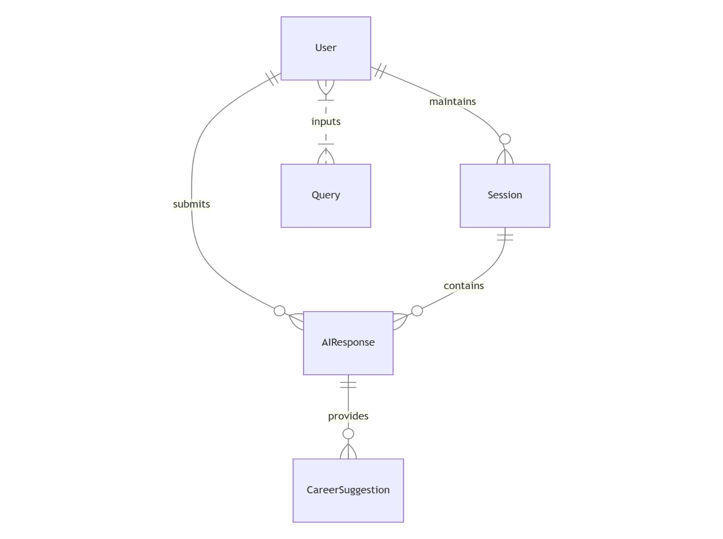Fig. 4.4.1

**4.4.1 User Entity**

* **Attributes**: Name (optional), Input Query, Session ID
* **Role**: Submits career-related queries

**4.4.2 AI Response Entity**

* **Attributes**: Processed Output, Suggested Careers, Additional Resources
* **Role**: Provides relevant career guidance based on user input

**4.4.3 Session Entity**

* **Attributes**: Session ID, User Queries, AI Responses
* **Role**: Maintains session-based interactions for a personalized experience

This approach ensures a structured and meaningful interaction between system components without requiring a database.

# Implementation

**5.1 Project Structure**

The project follows a modular design, with different components handling specific functionalities. The structure is as follows:

AI_Advisor/

│── frontend/ # UI Components

│ ├── Home.js # Main webpage

│ ├── Home.css # Styling for the frontend

│ ├── CareerRecommendation.js # Handles career recommendation

│ ├── CareerRecommendation.css # Styles career recommendation

│ ├── InteractiveChat.js # Handles career chatbot

│ ├── InteractiveChat.css # Styles career chatbot

│ ├── JobMarketTrends.js # Handles Job Trends

│ ├── JobMarketTrends.css # Styles Job Trends

│ ├── Resumevetter.js # Vets Resume

│ ├── Resumevetter.css #Styles resume vetter

│── backend/ # API and logic handling

│ ├── main.py # Main Flask or FastAPI application

# Utility functions

│── package.json # Dependencies

│── README.md # Project documentation

Each file plays a key role in ensuring the proper execution of the AI-driven career advisory system.

**5.2 Frontend Implementation**

The frontend provides an interactive interface where users enter career-related queries and receive AI-generated recommendations.

**Home.js (Frontend main page)**

import React from "react";

import { Link } from "react-router-dom";

import "./Home.css";

import logo from '../assets/logo.png';

import backgroundImage from '../assets/ai-background.png';

const Home = () => {

return (

<div

className="home-container"

style={{

backgroundImage: `url(${backgroundImage})`,

backgroundSize: "cover",

backgroundPosition: "center",

minHeight: "100vh",

}}

>

<img src={logo} alt="Career Advisor Logo" className="logo" />

<div className="content">

<p className="quote">

🌍 Studies show that over 70% of people work in careers that don’t match their skills or interests.

For instance, in India, only 8.25% of graduates are employed in roles that align with their qualifications.

This highlights a significant mismatch in the workforce, with many individuals underemployed or working in positions that don't utilize their full potential.

Finding the right career can boost job satisfaction, productivity, and success.

Why settle for less when you can find your perfect path?

</p>

<h1 className="headline">Let’s Choose the Best Career Path 🚀</h1>

<Link to="/recommendation">

<button className="start-button">Get Started</button>

</Link>

</div>

</div>

);

};

export default Home;

**Home.css (Basic Styling)**

.home-container {

  background-image: url('../assets/ai-background.png');

  background-size: cover;

  background-position: center;

  min-height: 100vh;

  width: 100%;

  color: white;

  display: flex;

  flex-direction: column;

  align-items: center;

  justify-content: center;

  position: relative;

  padding: 2rem;

  text-align: center;

  box-sizing: border-box;

}

.logo {

  position: absolute;

  top: 10px;

  left: 10px;

  width: 130px;

  height: auto;

  z-index: 10;

}

.content {

  max-width: 90%;

  margin-top: 3rem;

}

.quote {

  font-size: 1.8rem;

  font-weight: 400;

  margin-bottom: 2rem;

  line-height: 1.8;

  text-shadow: 1px 1px 2px rgba(0,0,0,0.6);

}

.headline {

  font-size: 2.5rem;

  font-weight: 600;

  margin-bottom: 2rem;

}

.start-button {

  padding: 2rem 3rem;

  font-size: 2rem;

  font-weight: bold;

  background-color: #00cc66;

  color: white;

  border: none;

  border-radius: 8px;

  cursor: pointer;

  transition: background 0.3s ease;

}

.start-button:hover {

  background-color: #00b359;

}

@media (max-width: 768px) {

  .logo {

    width: 100px;

    top: 5px;

    left: 5px;

  }

  .quote {

    font-size: 1rem;

  }

  .headline {

    font-size: 1.5rem;

  }

  .start-button {

    width: 80%;

    font-size: 1rem;

    padding: 0.8rem;

  }

}

**5.3 Backend Implementation**

The backend is responsible for processing the user's input, forwarding it to the AI model, and returning structured career advice. It is implemented using Flask or FastAPI.

app.py (Flask API for Handling Requests)

from fastapi import FastAPI, HTTPException

from fastapi.middleware.cors import CORSMiddleware

from pydantic import BaseModel

from typing import Optional

import requests

import os

from dotenv import load_dotenv

from bs4 import BeautifulSoup

import PyPDF2

import io

from typing import Dict, List

import re

from fastapi import FastAPI, HTTPException, UploadFile, File, Form, status

from fastapi.responses import JSONResponse

import json

from datetime import datetime

load_dotenv()  # Load environment variables from .env file

app = FastAPI(

    title="AI Career Advisor API",

    description="API for career recommendations, chat assistance, and job trends",

    version="1.0.0"

)

app.add_middleware(

    CORSMiddleware,

    allow_origins=["*"],  # In production, specify exact origins

    allow_credentials=True,

    allow_methods=["*"],

    allow_headers=["*"],

)

class CareerRequest(BaseModel):

    name: Optional[str] = None

    ageGroup: str

    qualification: str

    skills: str

    interests: str

    workStyle: str

    experience: str

    subjects: Optional[str] = None

    hobbies: Optional[str] = None

    learningStyle: str

    priority: str

    personalityType: Optional[str] = None

    preferredIndustries: Optional[str] = None

    longTermGoal: Optional[str] = None

    workingHours: Optional[str] = None

    travelWillingness: Optional[str] = None

class ChatRequest(BaseModel):

    message: str

    model: Optional[str] = "llama3-8b-8192"  # Default model

class ResumeVettingRequest(BaseModel):

    resume_text: Optional[str] = None

    resume_pdf: Optional[bytes] = None

    job_description: Optional[str] = None

    model: Optional[str] = "llama3-70b-8192"

    analysis_type: Optional[List[str]] = ["ats", "skills", "structure"]  # New: Specify analysis types

import PyPDF2

import io

def extract_text_from_pdf(pdf_bytes: bytes) -> str:

    """Extract text content from PDF bytes."""

    try:

        reader = PyPDF2.PdfReader(io.BytesIO(pdf_bytes))

        text = "\n".join([page.extract_text() for page in reader.pages if page.extract_text()])

        return text.strip() if text else ""

    except Exception as e:

        raise HTTPException(

            status_code=400,

            detail=f"Failed to process PDF: {str(e)}"

        )

def handle_api_error(e: Exception, service_name: str) -> None:

    """Handle API errors consistently"""

    error_msg = f"{service_name} API Error: {str(e)}"

    if isinstance(e, requests.exceptions.RequestException):

        error_msg += f" | Status Code: {e.response.status_code if hasattr(e, 'response') else 'Unknown'}"

    raise HTTPException(status_code=500, detail=error_msg)

def call_groq_api(prompt: str, model: str = "llama3-8b-8192") -> str:

    """Generic function to call Groq API"""

    groq_api_key = os.getenv("GROQ_API_KEY") or "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"

    url = "https://api.groq.com/openai/v1/chat/completions"

    headers = {

        "Authorization": f"Bearer {groq_api_key}",

        "Content-Type": "application/json"

    }

    data = {

        "model": model,

        "messages": [

            {

                "role": "system",

                "content": "You are a professional career counselor with 20 years of experience."

            },

            {

                "role": "user",

                "content": prompt

            }

        ],

        "temperature": 0.7,

        "max_tokens": 1024,

        "top_p": 0.9

    }

    response = requests.post(url, headers=headers, json=data)

    response.raise_for_status()

    result = response.json()

    return result["choices"][0]["message"]["content"]

@app.post("/chat/", summary="Chat with AI assistant")

async def chat_with_bot(payload: ChatRequest):

    """

    Chat with AI assistant about career-related questions.

    """

    try:

        response = call_groq_api(payload.message, payload.model)

        return {

            "response": response,

            "model": payload.model

        }

    except Exception as e:

        handle_api_error(e, "Groq Chat")

# References

1. Patel, R., & Lee, M. (2022). Large Language Models in Personalized Career Counseling. AI & Society, 37(2), 225-239.
2. Smith, J., & Brown, K. (2021). AI in Career Guidance: Opportunities and Challenges. Journal of Career Development, 48(3), 345-360.
3. Generative Artificial Intelligence (AI) on Sustainable Development Goal#4 for Tertiary Education: Conversational AI With User-Centric ChatGPT-4. (2024). Researchgate. <https://doi.org/10.4018/979-8-3693-2418-9.ch010>
4. European Commission (2021). Proposal for a Regulation laying down harmonised rules on Artificial Intelligence. COM (2021) 206. https://digital strategy.ec.europa.eu/en/library/proposal-regulation-laying-down-harmonised-rules artificial-intelligence
5. European Commission (2019). Key Messages on Artificial Intelligence in Education Education & Training 2020 Working Group on Digital Education: Learning, Teaching and Assessment. Accessed from https://ec.europa.eu/social/vocationalskillsweek/sites/evsw/files/ai_key_messages_final_and_es.pdf
6. AI4People—An ethical framework for a good AI society: Opportunities, risks, principles, and recommendations. Minds & Machines, 28, 689–707. https://doi.org/10.1007/s11023-018-9482-5
7. Fusco, L., Parola, A., & Sica, L. S. (2020) Designing meaningful career tools: a proposal for an optimal use of technology in career guidance. Proceedings of the Second Symposium on Psychology-Based Technologies.
8. Holmes, W., Porayska-Pomsta, K., Holstein, K., Sutherland, E., Baker, T., Buckingham Shum, S., Santos, O. C., Rodrigo, M. T., Cukurova, M., Igbert Bittencourt, I., & Koedinger, K. R. (2021). Ethics of AI in Education: Towards a Community-Wide Framework. International Journal of Artificial Intelligence in Education. https://doi.org/10.1007/s40593-021-00239-1.
9. ääskelä, P., Heilala, V., Kärkkäinen, T., & Häkkinen, P. (2020). Student agency analytics: Learning analytics as a tool for analysing student agency in higher education. Behaviour & information technology, 40(8). https://doi.org/10.1080/0144929X.2020.1725130
10. Attwell, G., Bekiaridis, G., Deitmer, L., Perini, M., Roppertz, S., & Tutlys, V. (2020). Artificial intelligence in policies, processes and practices of vocational rducation and training. Institut Technik und Bildung, Universität Bremen.
11. Bakke, I.B., Hagaseth Haug, E., & Hooley, T. (2018). Moving from information provision to co-careering: Integrated guidance as a new approach to e-guidance in Norway. Journal of the National Institute for Career Education and Counselling, 4(1), 48–55. <https://doi.org/10.20856/jnicec.4108>
12. Bandura, A. (2001). Social cognitive theory: An agentic perspective. Annual Review of Psychology, 52, 1–26. <https://doi.org/10.1146/annurev.psych.52.1.1>
13. Bandura, A. (2006). Toward a psychology of human agency. Perspectives on Psychological Science, 1(2), 164–180. <https://doi.org/10.1111/j.1745-6916.2006.00011.x>
14. Barnes, S.-A., Bimrose, J., Brown, A., Kettunen, J., & Vuorinen, R. (2020). Lifelong guidance policy and practice in the EU: trends, challenges and opportunities. Final report. Publications Office of the European Union. <https://doi.org/10.2767/91185>
15. Cedefop, European Commission, ETF, ICCDPP, ILO, OECD, & UNESCO (2020). Career guidance policy and practice in the pandemic: results of a joint international survey June to August 2020. Publications Office of the European Union. <http://data.europa.eu/doi/10.2801/318103>
16. Cox, A. M. (2021). Exploring the impact of Artificial Intelligence and robots on higher education through literature-based design fictions. International Journal of Educational Technology in Higher Education, 18(3). <https://doi.org/10.1186/s41239-020-00237-8>
17. Council of the European Union (2008). Council Resolution on better integrating lifelong guidance into lifelong learning strategies. <https://eur-lex.europa.eu/legal-content/EN/TXT/?uri=CELEX:42008X1213(02)>
18. Creswell, J. W., & Plano Clark, V. L. (2011). Designing and conducting mixed methods research (2nd ed.). Sage.
19. Eteläpelto, A., Vähäsantanen, K., Hökkä, P., & Paloniemi, S. (2013). What is agency? Conceptualizing professional agency at work. Educational Research Review, 10, 45 65. <https://doi.org/10.1016/j.edurev.2013.05.001>
20. European Commission (n.d.). Ethics guidelines for trustworthy AI. https://ec.europa.eu/futurium/en/node/6945.